HACETTEPE UNIVERSITY DEPARTMENT OF

COMPUTER ENGINEERING

BBM 453 LAB EXPERIMENT



Mehmet Taha USTA – 21527472

Çağlar USLU – 21808388

Mehmet Taha USTA Source = 192.168.1.39

Çağlar USLU Source = 192.168.0.10

**1.** **nslookup**

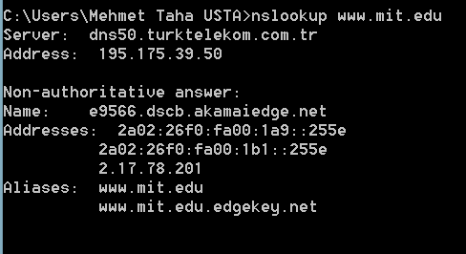

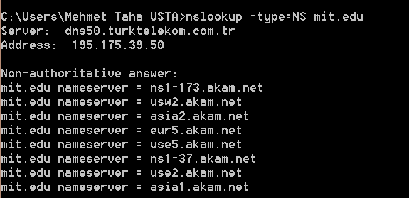

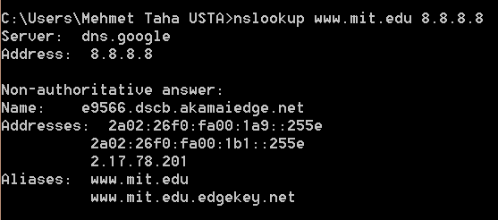

**Q1)** **Run nslookup to obtain the IP address of a Web server in Europe. What is the IP address of that server?**

**Q2)** **Run nslookup to determine the authoritative DNS servers for a university in United States.**

**Q3) Run nslookup so that one of the DNS servers of Google is queried for the mail servers for Yahoo! mail. What is its IP address?**

**2.** **ipconfig / ifconfig**

**2.1 ipconfig /all**

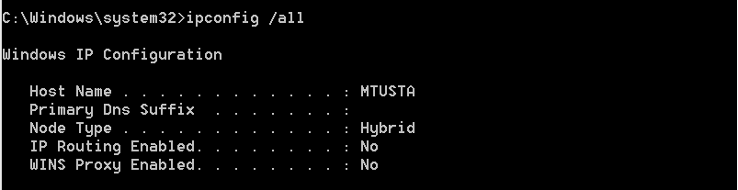

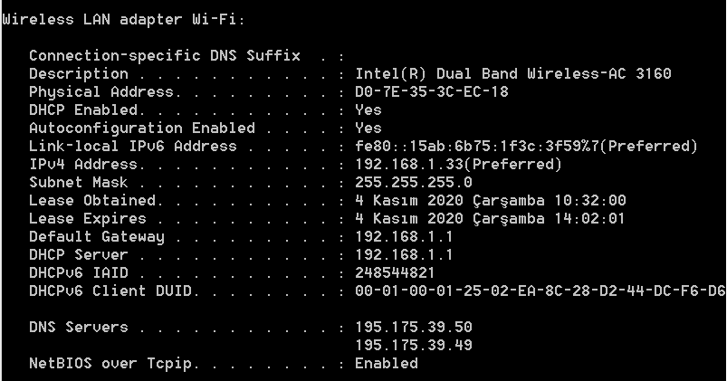

**2.2 ipconfig /displaydns**

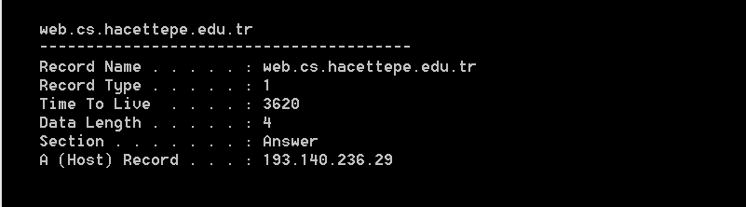

**2.3 ipconfig /flushdns**

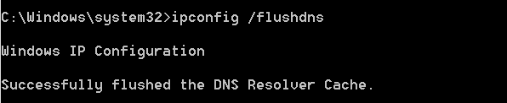

**3 Tracing DNS with Wireshark**